Implementation of a Simple Modem
(Final Report)

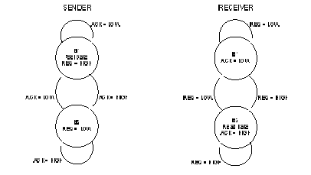

Ho, Hingkei SID: 103 079 575
Vega, Roberto Javier SID: 003 110 717
CS152A / EE116L
LAB 6, Sec 4 T.A. Wendong, Hu

Introduction:

In this lab, we were to implement the logic of a simple modem, which is a design that allows the transmission of data from one circuit (sender) to another (receiver). The circuit was supposed to implement a method of handshaking for the correct transmission of the data bits and the acknowledgment of that data. The modem also needed to support encryption of the data to be transfer. To implement the encryption of the data we used simple shifting of bits from the data, and then unshifting of the data bit to unencrypt the data bits.
The basic unit of data transmission was:
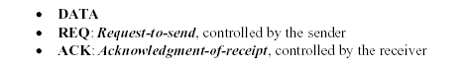
The handshaking protocol had the following sequence:

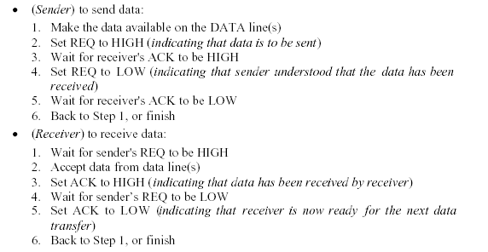

From this specification the following diagram showed the data flow:

To build the circuit we started with the first level of protocol between the user X and the sending machine (the sender). The user flags the sender using the X_REQ signal saying that the user has either an encryption value, the first four bits of data, the second four bits of data, or wants to start running the process of sending after all entries have been received by the sender. We added the fourth one to signal to the sender that we are ready for the sender to take over and do its thing with the receiver on its own. At each flag of X_REQ the sender acknowledges the user input after storing the values in the proper registers. Using the S_ACK signal. After this the sender and receiver proceed to exchange requests and ACKs for each bit of data being sent over the single bit data. Once the sender has the data, it will decrypt it and then present the lower four bits to the receiving user Y and then the upper four bits.
Attached are samples of waveforms, the graphic editor printouts, and the control module AHDL for the sender and receiver. We designed our system first by tackling the states of the sender, its respective inputs and outputs based on state, and then the circuit design and control circuit creation. Once this was done and working, we did the same to the receiver. We tested both parts independently and they both worked at expected. We preformed several scenarios and data on the sender and we were able to narrow down most of the possibilities. After having both circuits working we proceed to tested together and unfortunately our results weren’t as expected. For some reason, unknown for us once the lab was over, the machines weren’t able to communicate as designed. We tried to discover the problem but after many attempts we couldn’t figure out exactly why the did not work together on the circuit board, but worked on the digital design.

